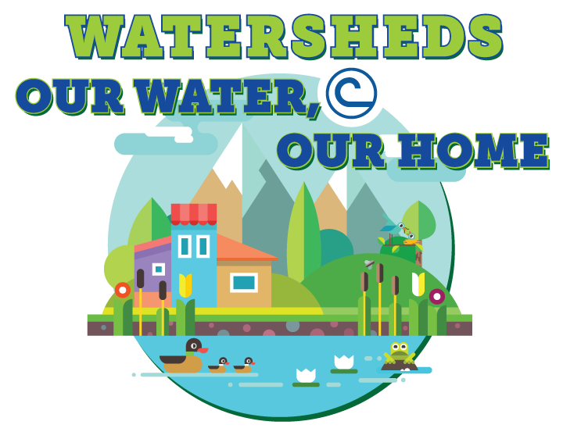

2018 National Association of Conservation Districts Poster Contest Entry Form

Entry Level
Grades 4-6______ Grades 7-9______
Each poster entry must be accompanied by this entry form taped to the back of the poster.
Posters due Friday, March 16th

Student Information

First: ______________________ Middle: _______________ Last: ________________________

Address: ______________________________________________________________________

City: ________________________ State:____ Zip: _________ Grade: _____ Age: _______

Parent/Guardian Name: __________________________________________________________

Contact Phone: (___)_______________ Contact E-mail: _____________________________

I allow NACD and the Pickaway Soil and Water Conservation District to utilize this poster submission for educational and/or promotional purposes.

_______________________________________________ ______________
Signature of Parent/Guardian Date

______ This poster is an original, completed by the student named above.
______ The student received assistance from another person or materials/ideas from another source (if yes, please include explanation along with form).

School Information

Public School ____ Private School ____ Home Schooled ____

School Name: ______________________________________________________

Teacher: ___________________________________________________________

School Address: ________________________________________________________________

City: _______________________ State:_____ Zip:____________

Teacher E-mail: ______________________________________________________

Conservation District
Pickaway Soil and Water Conservation District
Contact: Montana McFarland, Education/Outreach Coordinator
montana-mcfarland@pickawayswcd.org
110 Island Road, Suite D, Circleville, OH 43113 (740)477-1693

